Stop the Dams Ordinance, the Ordinance of Ecocides, Stop the Government Quackery!

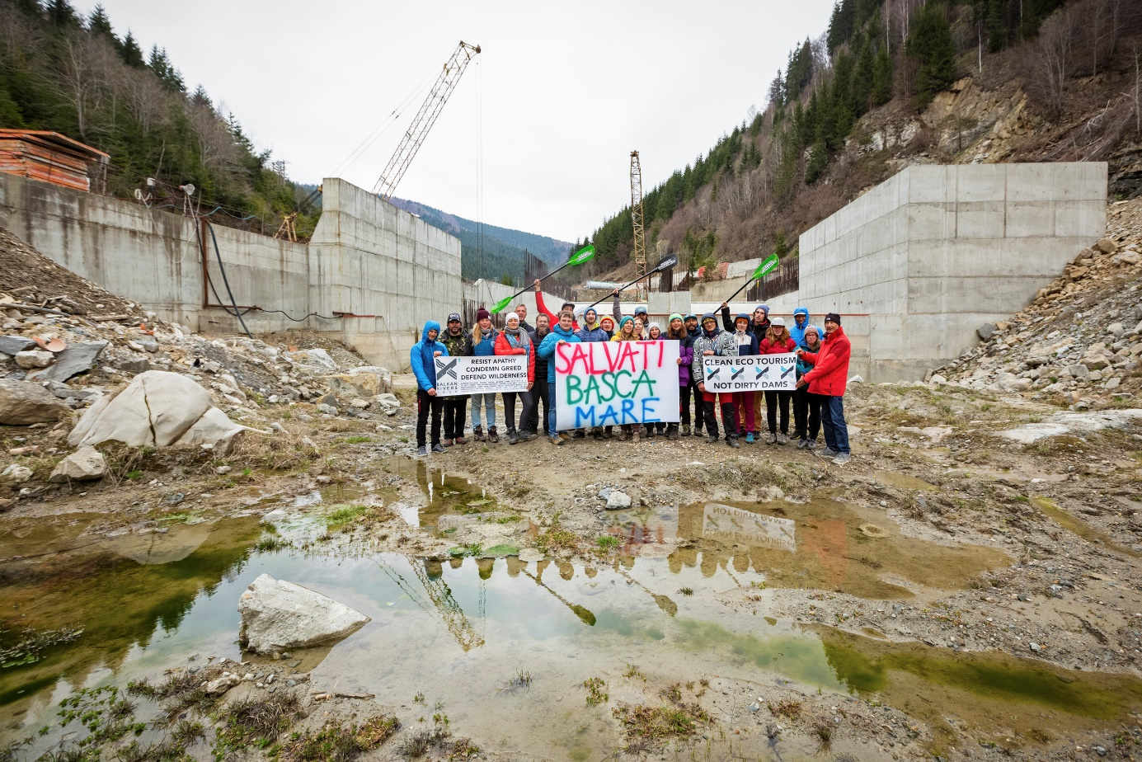

Open Letter to the European Commission and the President of Romania, Mr. Klaus Iohannis

The European Commission should without delay stop, through infringement, the ordinance of ecocides. This is about the draft ordinance posted on the site of the Ministry of Energy from Romania.
https://energie.gov.ro/proiect-de-ordonanta-de-urgenta-pentru-stabilirea-unor-masuri-privind-obiectivele-de-investitii-pentru-realizarea-de-amenajari-hidroenergetice-in-curs-de-executie-precum-si-a-altor-proiecte-de-interes/
The infringement case for illegally approved small diversion hydropower plants is open (2015/4036), and in 7 years nothing has been solved, the situation has even worsened by violating the final court sentence for the Taia River. According to the Leibniz Institute in Berlin, considering not the installed capacity but the extremely low potential production and the diversion type, the hydropower project in Jiu Gorge represents a small hydropower project.
https://www.igb-berlin.de/en/news/small-hydropower-plants-do-more-harm-good

Analogously, the situation is the same with the Nehoiașu II hydropower plant (”AHE Surduc Siriu”). The Commission closed the complaint CHAP(2016)01813 on the grounds that the final decision of the Bucharest Court of Appeal (no. 5378/2017) resolved the case. But ordinance of ecocides violates decision 5378/2017. The ordinance of ecocides involves the destruction of dozens of Natura 2000 sites and bodies of water, bypassing environmental assessment. And three of the 9 illegal projects in the ordinance have a cumulative impact with projects exemplified in infringement no. 2015/4036 (with those on Ramna, Taia and the projects in the east of the Făgăraș Mountains). Considering the above, the European Commission must act quickly, ascertain that the ordinance of ecocides represents an exponential, ostentatious aggravation of the infringement 2015/4036 and immediately proceed to the contentious stage, send the case to the CJEU.
The President of Romania can stop the ordinance of ecocides, he can physically participate in government meetings and prevent its adoption. It is, after all, a kind of ”OUG 13”, intended to cover those who carried out illegal works on public money. IUCN has already addressed the President of Romania regarding the Zamfir law, which promoted the same illegal projects, but was ignored.
https://www.impact.ro/hidrocentralele-pe-arii-protejate-in-romania-scrisori-catre-klaus-iohannis-de-la-forurile-internationale-specialist-atat-de-tare-am-ajuns-sa-ne-facem-de-ras-429363.html
It seems that Romania is no longer part of the civilized world. The ordinance of ecocides is actually similar to the Şarapatin law, the Romanian president should show consistency, given the arguments he used to request the review of the Şarapatin law (CA/726/26.07.2019).
Saving the Bâsca Mare River has been enthusiastically received by civil society throughout Europe, and it is a national shame that efforts to dry up this emblematic river are being resumed.
https://balkanriverdefence.org/news/romanian-basca-mare-river-is-saved/
The dam on Bâsca Mare is also given as a negative example in the first IUCN guide on ecological connectivity.
https://portals.iucn.org/library/sites/library/files/documents/PAG-030-En.pdf

It is the darkest moment in history for the natural heritage, for the natural setting of Romania. The neo-ceaushist government in Bucharest tramples the rule of law, the Constitution, the European legislation and the conventions signed by Romania, it wants to exempt even the projects with the worst environmental impact, the ceaushist dams, from the environmental impact assessment. It is about 9 unprofitable hydropower projects that, for an insignificant and extremely expensive production, would devastate the natural heritage of the country, from the heart of the Jiu Gorge National Park to the Ramsar site at the confluence of the Olt and Danube rivers. Through the hundreds of millions of euros (public money) that they will swallow up and the production that will only start after many years and will contribute less than 1% in the National Energy System, the ceaushist projects only decrease, potentially, the electricity production. With these astronomical sums, more energy can be obtained, faster and legally, with minor environmental impact, by allocating them to sustainable, contemporary projects, or to retrofitting and unclogging to the existing hydropower plants, or even to prosumers.
The ordinance is claimed to be issued in order to obtain European funding until 2026, given that these ceaushist dams were prior included in the National Recovery and Resilience Plan and removed following the public consultation from the beginning of 2021. Now, some ministers nostalgic of Ceaușescu's dictatorship show their contempt for citizens and democratic rules and introduce illegal projects to European funding through the back door, this time using REPowerEU (which is not even about hydropower) as a pretext. It is stated that the motivation of the ordinance would be financial, grabbing European money, but European funding is only used as manipulation to promote criminal projects. The European Commission has already clarified that it will not finance hydropower plants in protected areas and will even trigger infringement if the law initiatives to promote them are brought to completion (Ares(2022)8053032 – 22/11/2022).
https://cursdeguvernare.ro/pensii-speciale-irigatii-energie-investitii-comisia-europeana-explica-din-nou-romaniei-ce-poate-si-ce-nu-poate-modifica-in-pnrr.html
It is therefore a case of government deception on an unprecedented scale.
All that is actually wanted is to violate the final court rulings and the environmental legislation of the European Union, to bypass the administrative documents already issued by the environmental authorities (which have already rejected 3 of the 9 projects), in order to authorize some unsustainable, absurd and harmful projects, which have no chance of being legally authorized. To teach a lesson to the judges who dared to respect the principle of the supremacy of community legislation, principle included in the Romanian Constitution. Behind it is the ambition of the ceaushist politicians to teach a lesson to the civil society that stopped the illegal works, so that they don't interfere in their illegal businesses in the future. It is also a manifestation of the disdain of the ceaushist politicians towards the citizens, since tens of thousands of Romanians signed 4 petitions contesting 4 of the 9 illegal projects.
The parliamentary process is bypassed, when the Zamfir law was rejected by the Constitutional Court of Romania and its subsequent duplication has already received two negative opinions. Never in the history of Romania has a legislative act been issued with such a devastating impact on the natural setting of Romania, its implementation would mean a coup de grace for the national and European natural heritage.
Even energy experts admit that the projects in question do not represent renewable energy, because their devastating impact is irreversible.

The 9 projects do not fit into the "green taxonomy" of the European Union, because they fragment the rivers. And they are not projects of overriding public interest because, according to the jurisprudence of the CJEU applied by the Supreme Court of Spain, in decision 424/2020 (and the application of CJEU jurisprudence must be uniform), studies are needed to balance the public interests involved, in order to determine which is overriding one, studies which do not exist.
It is not "just" about the drying up of the Jiu River on 33 kilometers, the deforestation of the Călimani National Park, the extermination of the Romanian huchens, the decrease of the range of some priority species, the deforestation of some priority habitats and the threat of extinction for endemic species, it is about a series of ecocides with an apocalyptic cumulative impact. It includes the mutilation of two national parks, a nature park, a Ramsar site, twenty Natura 2000 sites and tens of water bodies, in all corners of the country.
The natural heritage of Romania also belongs to the European one, the Commission must act promptly for the natural heritage of Romania, as it acted in the case of Poland, for Białowieża.

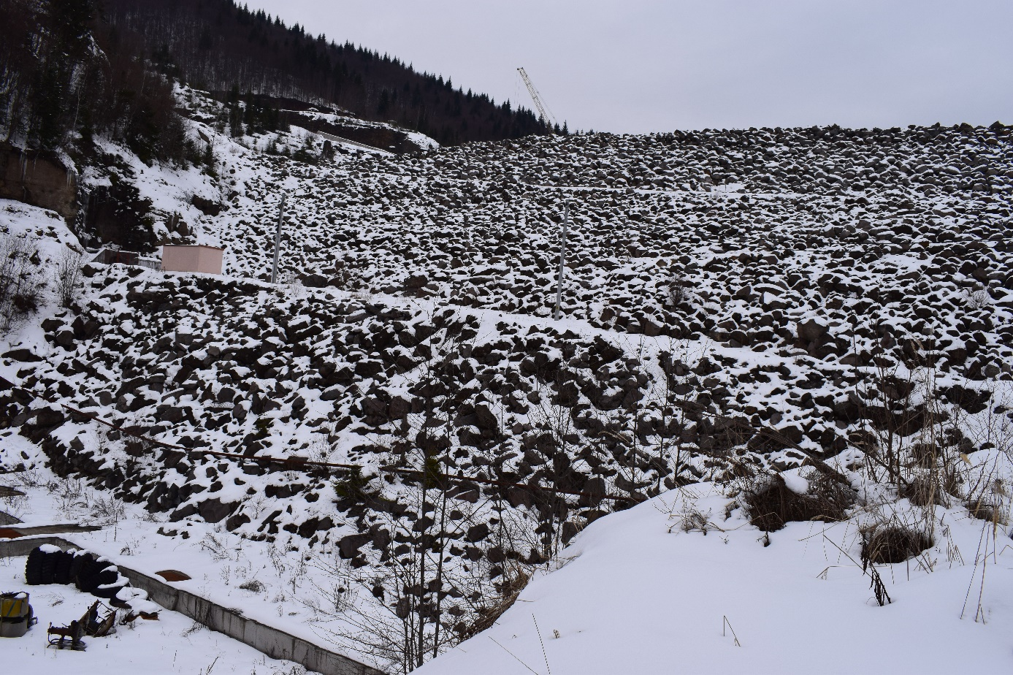

Dams represent the most serious form of destruction of nature. These clots on the veins of the Earth completely destroy river courses, floodplains and valley slopes. Forests, meadows and cultivated land are replaced by a liquid anthropogenic environment with no conservation value, classified by the IUCN as the Artificial Wetlands Biome (not lakes). The landscape, the natural setting are completely mutilated. Rivers are devastated along their entire length, not just the stretch directly affected.
In Europe, the "de-damming" movement has gained momentum, but the Romanian government is moving against the current, forgetting that there are already thousands of dams in Romania with a devastating cumulative environmental impact.
It is also an attempt to obstruct justice, to cover up those who have already carried out the illegal works, spending public money. For the millions of euros spent illegally on the destructions in Jiu Gorge National Park, there is a file dealt with at the National Anticorruption Directorate. On the very day that the European Commission requested the lifting of the Cooperation and Verification Mechanism for Romania, it is defied by the corrupt people in the government with an ordinance that breaches the Habitats Directive, the Water Framework Directive, the SEA Directive, the EIA Directive, Directive 2003/87/EC and jurisprudence of the CJEU.
This ordinance is associated to a huge pro-dams fake news campaign that preceded it, a campaign peppered with vulgar anti-European statements, a campaign that reminded us that Romania ranks 56th in the Press Freedom Index.
The promotion of these illegal projects, which represents a violation of national and community legislation, international conventions, obstruction of justice and violation of definitive court decisions, constitutes an attack on the rule of law and should lead to suspending of the funding of the National Recovery and Resilience Plan.
It is also a form of fraud of European funds. European funds were spent on studies/strategies, and their conclusions are now being trampled on, it means the financing was not used for its purpose. On the project with SMIS code 1314, it was concluded that the current river discharge must be maintained on Jiu River, in the Jiu Gorge Natura 2000 site, and the "Strategy for economic, social and environmental development of the Jiu Valley" provides for the prohibition of hydropower works on Jiu River, because this destruction is socioeconomically undermining the Jiu Valley. A LIFE-Nature project was implemented in Islaz, with WWF, SOR, the county environmental agencies and the Persina Nature Park from Bulgaria as partners.
These projects do not represent clean energy, the reservoirs release enormous amounts of methane and carbon dioxide, and blocking the hydrographic network, the natural movement of sediments, reduces carbon sequestration in the marine environment. The carbon sequestered by riparian and slope ecosystems that are impacted will also end up in the atmosphere. He massive works involved, including concrete production, have a colossal carbon footprint.
It is stated that this financing for REPower EU will be attached to the National Recovery and Resilience Plan, but the National Recovery and Resilience Plan has the "no significant harm" eligibility condition, so from the start none of the hydropower projects in question are eligible.
Emblematic elements of Romanian nature have already been destroyed by European funding (the course of the Tisa River, the mountain rivers of Făgăraș and Șureanu, etc.). If this phenomenon were to continue, it would mean that Romania has more to lose from joining the EU.
It violates not only all European environmental directives, but also the Ramsar Convention, the Convention on Biological Diversity, the Bern Convention, the Carpathian Convention, the European Landscape Convention, the Danube River Protection Convention and IUCN Resolution 008/2020.
The neo-ceaushist government does not only show its contempt for the European Union, but for the entire civilized world. About the illegal project in the Jiu Gorge, for example, was even written in Science magazine, and the petition to save the Jiu Gorge, now with 33 thousands signatures, is mentioned in the latest UN environmental report on Romania.
https://unece.org/sites/default/files/2021-12/ECE_CEP_189_0.pdf
The project at Islaz destroys the spectacular Ramsar site "Olt-Danube Confluence", a nature paradise.
https://peterlengyel.wordpress.com/2012/08/31/situl-natura-2000-confluenta-jiu-dunare/
If these projects of Ceaușescu are now approved absolutely abusively and undemocratically, by emergency ordinance, it means that, in terms of the environment, the foundation of the quality of life, and in terms of democracy, the Romanian Revolution took place in vain, the Romanians died in vain in December 1989.

Yours faithfully,
Biol. Călin Dejeu
member of WCPA/IUCN

